FINITE ELEMENT IMPLEMENTATION OF AN ELASTOPLASTIC-VISCOPLASTIC constitutive law for tunnels

Felipe Pinto da Motta Quevedo

Denise Bernaud

Samir Maghous

motta.quevedo@ufrgs.br

denise.bernaud@ufrgs.br

samir.maghous@ufrgs.br

University of Rio Grande do Sul/PPGEC

Osvaldo Aranha 99, Zip-Code, RS, Brazil

**Abstract.** The paper presents an efficient numerical integration scheme for coupled elastoplasticity-viscoplasticity constitutive behavior with internal-state variables standing for irreversible processes. In most quasi-static structural analyses, the solution to boundary value problems involving materials that exhibit time-dependent constitutive behavior proceeds from the equations integration handled at two distinct levels. On the one hand, the first or local level refers to the numerical integration at each Gaussian point of the rate constitutive stress/strain relationships. For a given strain increment, the procedure of local integration is iterated for stresses and associated internal variables until convergence of the algorithm. On the other hand, the second or global level is related to structure equilibrium between internal and external forces achieved by the Newton-Raphson iterative scheme. A review of the elastoplastic and viscoplastic model will be shown, following the coupling between these models. Particular emphasis is given in this contribution to address the first level integration procedure, also referred to as algorithm for stress and internal variable update, considering a general elastoplastic-viscoplastic constitutive behavior. The formulation is described for semi-implicit Euler schemes. The efficacy of the numerical formulation is assessed by comparison with analytical solution derived for deep tunnel in coupled elastoplasticity-viscoplasticity.

**Keywords:** Constitutive models; Elastoplasticity; Viscoplasticity; Deep Tunnel; Finite Element Method;

1. Introdution

An elastoplastic-viscoplastic constitutive law becomes important when the material behavior can’t be describe by the usual models like elastoplasticity or viscoplastic. This problem is characteristic of deep tunnels excavated in clay rockmass as described by Rousset [1]. In these cases plastification around the rockmass,gradual closing of the tunnel section, extrusion of the excavation face and overloading on the lining can develop over the construction time (short term), or even months and years after the construction of the tunnel (long term), which can lead to excessive deformations [2], entrapment of the machine [3] and damage to the lining.

In addition to the present work, elastoplastic-viscoplastic models applied to the problem of deep tunnels can be found in: Rousset [1], Piei [5], Purwodihardjo e Cambou [6], Kleine [7], Shafiqu et al. [8], Debernardi & Barla [9], Souley et al. [10], Manh et al. [11] e Vrakas & Anagnostou [12].

This work presents a numerical integration scheme for the elastoplastic-viscoplastic constitutive behavior.

For that, a brief bibliographical review will be made about each model separately and later its coupling.

Finally, the validation of this model will be presented, comparing its numerical solution with the analytical solution obtained by Piepi [5] of an unlined excavated tunnel under axisymmetric conditions.

1. Elastoplastic constitutive model

For problems with isothermal evolution, quasi-static in small transformations, the elastoplastic constitutive model can be described through the decomposition of the total strain tensor, the flow surface, the plastic flow rule, the hardening-softening law and the conditions of loading and unloading.

* 1. Decomposition of the total strain tensor

Considering the hypothesis of small transformations (which includes the hypothesis of small strains) we have that the total strain rate can be decomposed into an elastic and a plastic component:



Within the context of deterministic thermodynamic processes, the specific free energy, considering an isothermal evolution, can be decomposed according to:



where  is the set of internal variables (cohesion, friction angle…) related to the hardening-softening phenomenon. From Eq.2, the following constitutive relationships are obtained:



where  is the set of thermodynamic forces associated with internal variables ( scalar or tensor). From Eq. and Eq. the following constitutive relationship is obtained:



where  and  are fourth-order tensors representing the elastic and elastoplastic modulus, respectively.

* 1. Flow surface

A phenomenological characteristic observed in elastoplastic

materials is the existence of a limit within which the material behaves elastically. In isotropic materials, this domain is delimited by a hypersurface in the space of principal stresses, as follows:



where  is the flow function. This surface delimits the set of stresses that are elastically admissible (E. A.) and the set of stresses that are plastically admissible (P.A.) as follows:



Figure 1 illustrates, in a generical way, this domain.

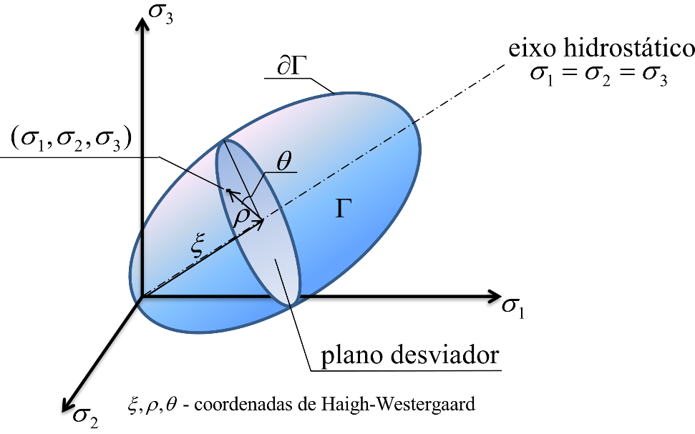

Figura 1. Domain plasticly admissible in the principal stress space.

The flow function is commonly described as a function of the invariants of the stress tensor and the forces associated with the internal variables related to the hardening and softening phenomenon, so that



with



In Eqs.(8),  are the coordinates of Haigh-Westergaard

(where is also known as the angle of Lode), is the hydrostatic pressure, is the equivalent stress of von-Mises , the normal and the octahedral shear, respectively, and  the tensor of deviator stress [13].

When the flow function does not depend of , it is said that the plasticity is independent of pressure, being determined only by the state of stresses along the desviator plane (Fig.1). Several flow functions can be found in the literature as in [13], [14] and [15].

* 1. Plastic flow rule

The law of evolution of plastic deformation (known as plastic flux) is postulated as



where  is the plastic multiplier and is the tensor that gives the direction of plastic flow through the gradient of a potential function analogous to . Like the flow function, the plastic potential is usually described using the invariants of the stress tensor and can be determined using the chain rule. For example, if

as in [16], we have:



As can be seen in Eqs.(10), the constants , and are particularities of each type of potential function. In [16] it is possible to obtain the value of these constants for several functions, such von-Mises, Tresca, Drucker-Prager, Mohr-Coulomb, Cap Models, etc.

* 1. Hardening-Softening law

The hardening-softening law characterizes the dependence of internal variables during the evolution of plastic deformations. This law is postulated as follows:



where  is known as the modulus of hardening. As the flow function  is dependent on the thermodynamic forces associated with the set of internal variables , the change of theses variables along the plastic deformation will change the position and or shape of the flow surface. When the flow surface is static, it means we have the perfect plasticity, when it increases, there is kinematic hardening and when it moves, there is kinematic hardening, being mixed, composed of the last two.

* 1. Loading and unloading conditions

The evolution of Eq. and Eq. are subject to three conditions (conditions of Kuhn-Tucker), which are:



These conditions establish that plastic flow only occurs when the state of stresses is on the flow surface and, in this case, there is no variation of the flow function in relation to the stresses, that is:



Eq. is known as the consistency condition.

* 1. Plastic multiplier and continuous Elastoplastic Module

Introducing Eq. to Eq. and Eq., together with Eq., and isolating the plastic multiplier, we have:



Which introduced in Eq. leads to:



Where  represents the tensor product. Through Eq. it can be noted that if plasticity is associated, the elastoplastic constitutive tensor is symmetric. Also, by the sign of the second term, it can be seen that plasticity represents a reduction in the material’s modulus of elasticity.

1. Viscoplastic constitutive model
   1. Decomposition of the strain tensor

The viscoplastic constitutive model has a rationale similar to that of elastoplasticity, which leads to the following relationship:



where  is the viscoplastic fourth order tensor.

* 1. Flow surface

Viscoplasticity does not always have an elastic domain, for example, at high temperatures certain materials can always flow under tension, that is, the flow function is zero. For these materials there are explicit functions [17], [18] and [19]. However, in problems involving deep tunnels, the phenomenon occurs from a certain level of stress, as described by [1]. For these cases, surfaces similar to those of elastoplasticity are used.

* 1. Viscoplastic flow rule and hardening-softening law

Analogous to elastoplasticity, the viscoplastic flow rule and the hardening-softening law are postulated as follows:



where  is the viscoplastic flow (or viscoplastic strain rate) 

is the magnitude of the viscoplastic strain and  is the viscoplastic flow vector, defined in the same way that of elastoplasticity, that is, through the gradient of a potential function, however viscoplastic.The hardening law can be described as a function of the equivalent viscoplastic deformation over time.

* 1. Viscoplastic multiplier

Unlike elastoplasticity, viscoplastic deformation occur even when , and therefore, the consistency condition is not imposed. Thus, the rate of the viscoplastic multiplier cannot be obtained from a condition like . Therefore, there are models that provide an explicit expression for and in this work Perzyna model [20] will be adopted, as described in Zienkiewicz e Cormeau [15]:



where  is the overtension function,  is the dynamic viscosity constant,  is the dimensionless parameter that gives the form of the power law ,  a parameter conveniently adopted andis the

é a constante de viscosidade dinâmica,  é o parâmetro admensional que dá a forma da lei de potência,  parâmetro convenientemente adotado e  is the McCauley function which is null when , that is, viscoplastic flow will only occur when the criterion is positive.

The proposed elastoplastic-viscoplastic model is constructed by the serial association of the constitutive models described above, and, therefore, we have:



This association can be seen in the one-dimensional representation of Fig.2.

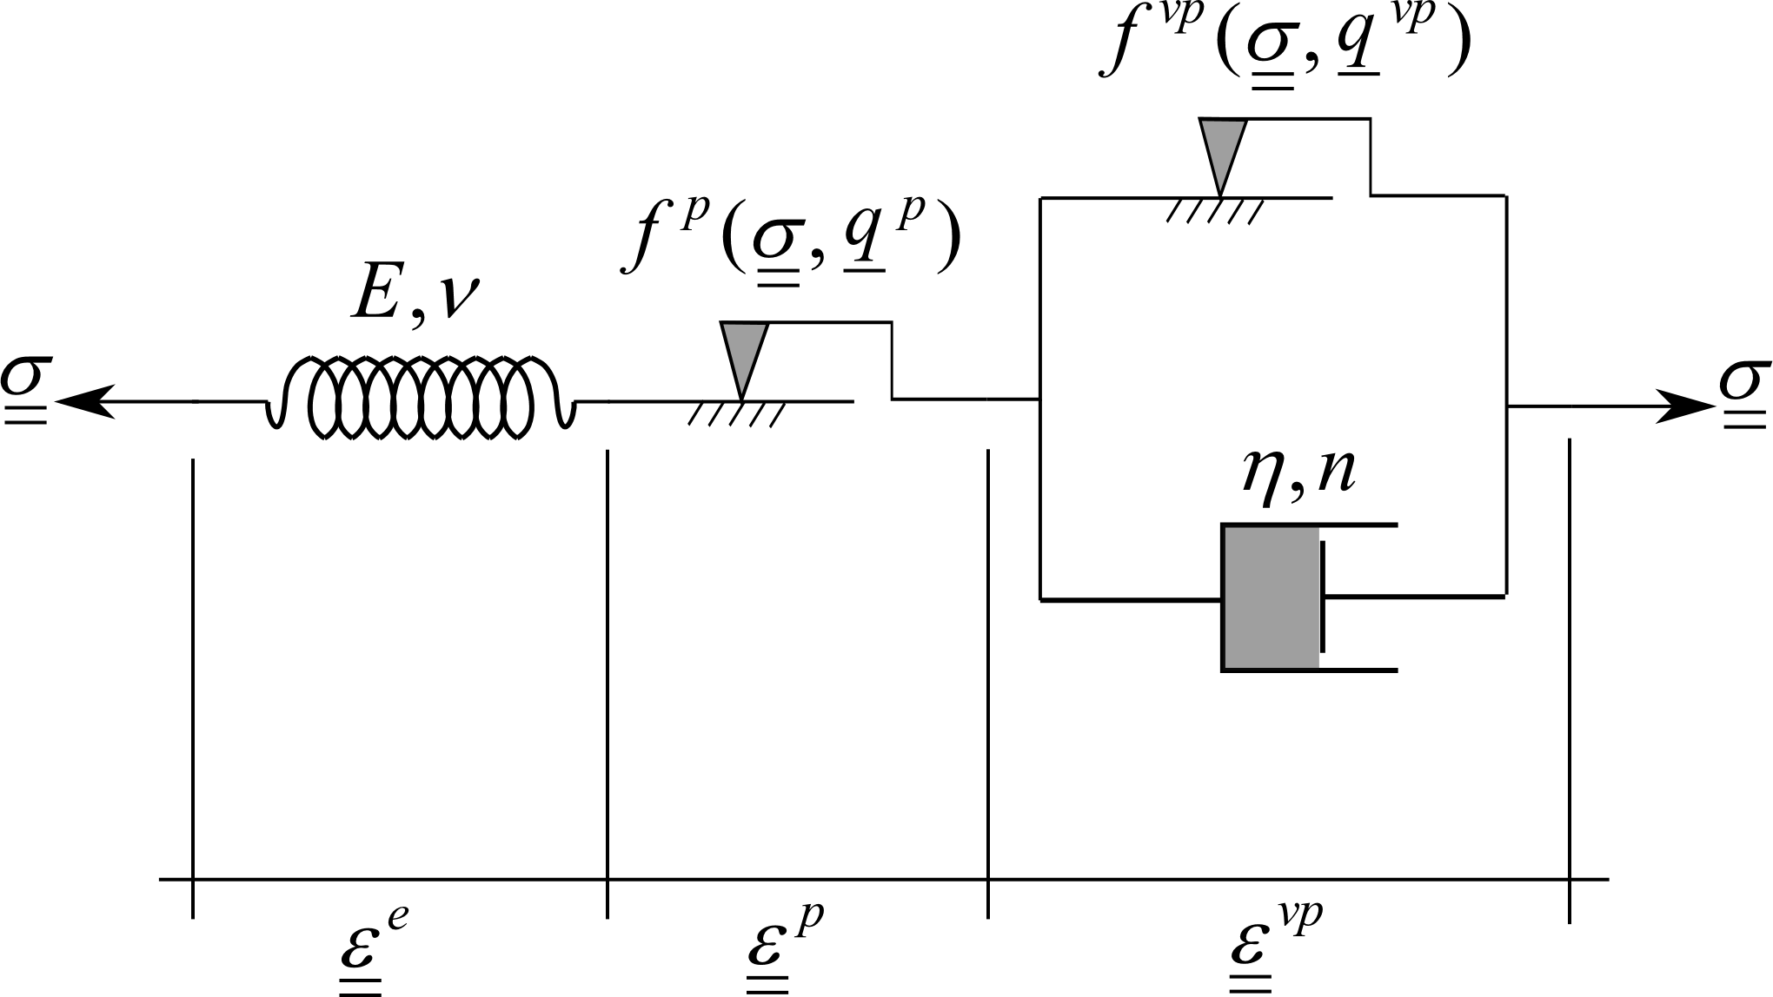

Figura 2. Rheological representation of the elastoplastic-viscoplastic model [1]

An important observation is that the flow surfaces and the internal variables that define the elastoplastic and viscoplastic portion of this model can be different from each other, including the association of their respective potential functions with their flow surfaces. Generally, viscoplasticity parameters are chosen so that its viscoplastic surface is inside the elastoplastic-viscoplastic surface, thus having the domains represented in Fig.3.

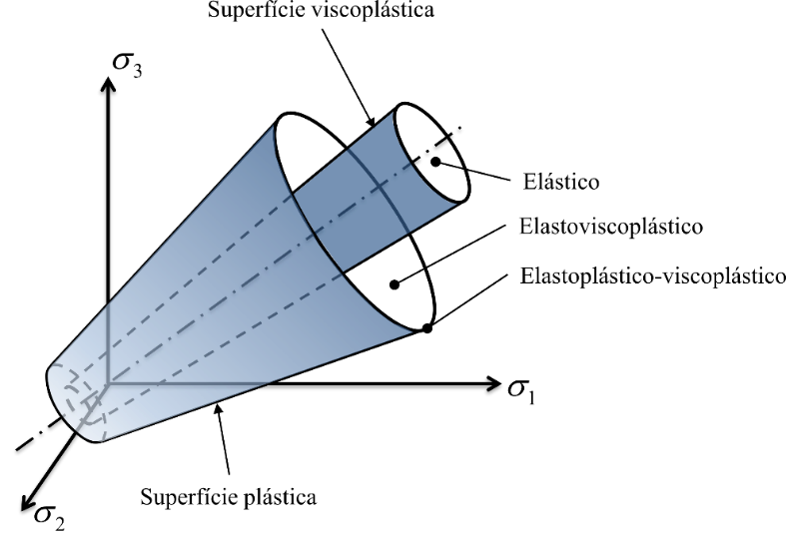

Figura 3. Domains and surfaces of the elastoplastic-viscoplastic model.

1. Solution of nonlinear constitutive problems in finite elements

Though the weak form of the field equations that govern the problem and the spatial discretization of the domain in finite elements, for quasi-static problems, isothermal in small transformations, we have the following set of nodal equations to be solved:



where  is the global stiffness matrix resulting from the assembly of the stiffness matrices of each element ,is the incognito vector of global nodal displacements resulting from the assembly of nodal displacements of each element, are the global forces resulting from volume, surface from the assembly of respective forces of each element.

When there is non-linearity involving the constitutive laws of the materials, the coefficient matrix  becomes dependent on the unknown nodal displacements , making the system non-linear.The Newton-Raphson method is the iterative process commonly used to solve this system. Therefore, approximating the system by a Taylor series truncated in the first order, we have the following iterative expression to approximate :

:



Where is the increment of nodal displacemetns of current iteration of the current iteration , are the internal forces of current iteration, is the unbalanced load vector (also called residual) for the current iteration, is the tangent global matrix,

are the node displacements in the current iteration and are the updated nodal displacements.

In order to incorporate the dependence of the load history, Eq. is discretized into substeps in which the external load and or time are linearly incremented, and therefore:



where  and are the array containing the finite element shape functions. In the computational implementation it is common to use the matrix form given by Voigt’s rules [25] instead of the tensor representation. In this paper, the Voigt’s notation will be used, but with the same symbology as tensor notation.

In Eqs.  and  are the external forces and the time at the end of the step, respectively.são as forças externas e o tempo no final do passo, respectivamente. At the beginning of the iterative process , ,  and are null. For the next substeps,the values of  e  correspond to the values of the previous solution .

1. Algorithm for updating the stress and internal variables

The algorithms for updating stress and internal variables propose to solve the system of differential equations involving the constitutive relations through some integration scheme (generally Runge-Kutta).

The algorithm occurs for each Gauss point of each element during the equilibrium iterations and, given a known set of in the iteration  and the increment of total strain we try to obtain the values of the next iteration where is the inelastic strain (plastic or viscoplastic).

* 1. Integration of elastoplastic constitutive equations

Using the first order Runge-Kutta method we have the following scheme of integration of the constitutive equations:

 where  and  provides the generalized trapezoidal rule for plastic flow and the evolution of internal variables. When  we obtain the form fully explicit and  the fully implicit. Semi-implicit algorithms adopt .

The completely explicit schemes, for example, adopted in [21], [22] and [23], were widely used until Simo and Taylor [24] proposed an implicit two-step predictor-corrector method. Therefore, the completely explicit schemes did not satisfy the consistency condition at the end of the step, since the plastic multiplier and the flux vectors were calculated with the stress of the previous step . Currently, completely implicit or semi-implicit algorithms that satisfy are used and some semi-implicit ones avoid the need to calculate the second order gradients of flow vectors  and , but need more equilibrium iterations in relation to the fully implicit scheme. Several integration schemes for elastoplasticity can be found in [14], [25] and [26].

In this work, a semi-implicit integration scheme, developed by Moran et al. [27], in which the plastic multiplier is integrated through an implicit scheme and the flow vectors are explicitly integrated. Therefore, we have from Eqs. the following integration scheme:



Two-step integration schemes have two steps: first, the elastic predictor is calculated and, if necessary, the plastic corretor. Defining , the elastic predictor can be explained from Eq.4 ou Eq.4 as:



where  is the elastic predictor (also known as tentative stress). Thus, in the first step, the tentative stress is calculated and the flow function . If  the stress state is in the elastic domain and there is no need to apply the plastic corrector. However, if  the stress state, it means that the stress state is outside the plastically admissible domain, it is necessary to apply the plastic corrector step.

The plastic corrector is nothing more than the system solution procedure 2,3,5 or 2,3,5 which will determine the increments  and . When it is not possible to obtain an analytical solution for this system, the commonly used solution procedure is the Newton-Raphson one, which iterates  times through the space of the stresses and internal variables until the stress state returns on the flow surface. This is why these schemes are also known as return mapping algorithms. Fig. 6 geometrically illustrates this solution.

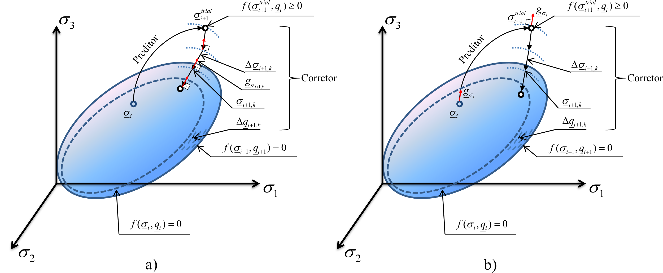

Figure 6. Illustration of the mapped return algorithm: a) fully implicit and b) semi-implicit with  Newton-Raphson local iterations

Therefore, to solve by Newton-Raphson the system that gives the beginning to the plastic corrector writes in the in the following residual (omitting the index ):



Linearizing the system in relation to , knowing that give:



Eqs. comprise a system of three equations with three unkowns: ,andand as the flow vectors and  are calculated in the initial step , their gradients did not appear in the formulations. Reorganizing this system we obtain the following solution for the plastic corrector:







Due to this explicit treatment of the flow vectors in Eq.

Presents a closed expression for involving only the elastic modulus. In addition, as the system is composed of linear functions in relation to the residuals and will automatically be null, dispensing its verification in the convergence criterion, as pointed by [25]. The flowchart can be seen in Fig.7.

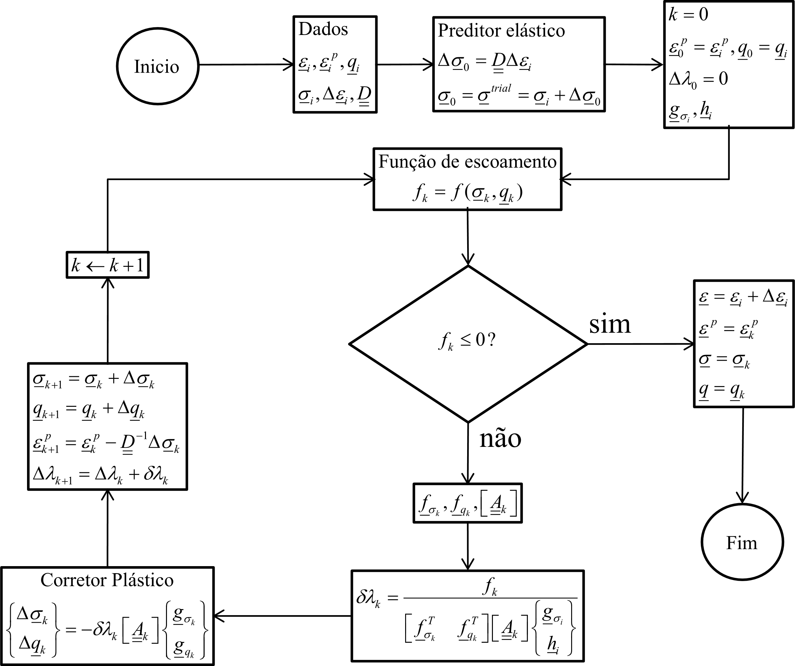

Figura 7. Integration algorithm for elastoplasticity using a semi-implicit Euler scheme (omitting the index )Integração das equações constitutivas viscoplásticas

Different integration algorithms can be found in the literature, such as in 28], [29], [30], [31], [32] and some of the most used in [25], [14], [33] and [34]. For the present work, a scheme introduced by Pierce et al. [31], known as the Rate Tangent Modulus Method, which comprises an explicit Euler scheme for all variables, except for that is integrated according to the generalized trapezoidal rule. So, we have the following scheme:



Linearizing the overstress of Eq. we have:



Replacing Eq. in the Eq.5 we obtain:



And introducing Eq.2  into Eq.4 and rewriting

Eq.3 we obtain:

:



Finally, replacing Eq. in Eq. we can isolate :



When we have a semi-implicit algorithm and when we have a fully explicit algorithm with . As can be seen from this deduction, unlike the integration of the constitutive equations of elastoplasticity is no need to iteratively solve a system. This aspect will facilitate the coupling between the viscoplasticity and elastoplasticity algorithms. The flowchart of this method can be seen in Fig.8.

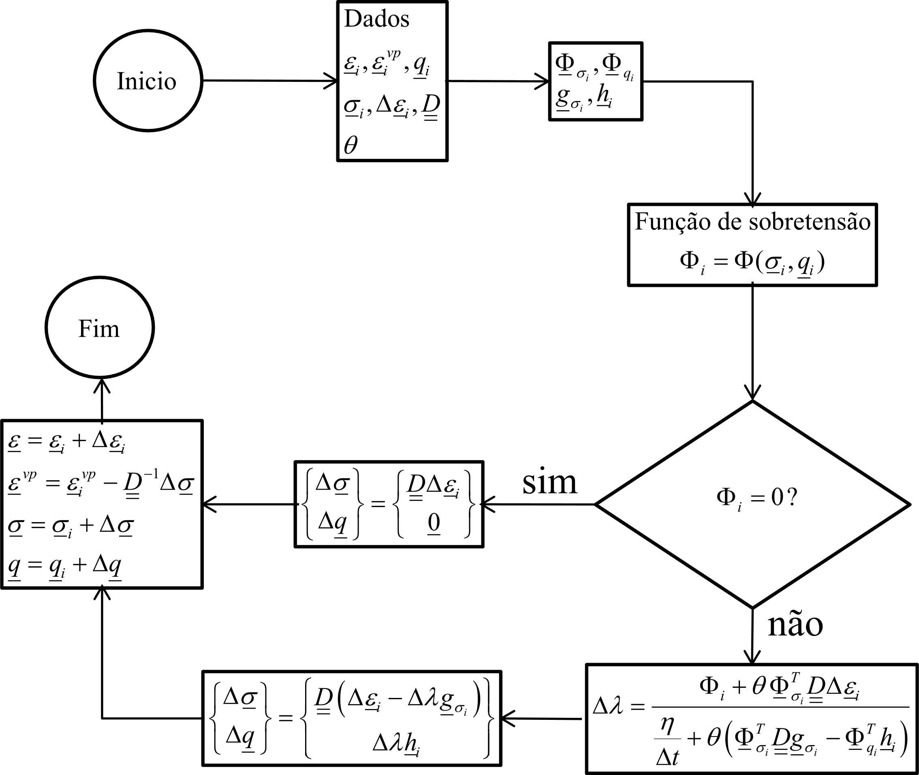

Figure 8. Integration algorithm for viscoplasticity using a semi-implicit Euler scheme (omitting the index )

* 1. Integration of elastoplastic-viscoplastic constitutive equations

As viscoplasticity is integrated through a semi-implicit rule in which all variables are calculated in step , that is, with the known stress, the viscoplastic strain increment can be directly discounted from the total strain increment in the elastic prediction step of the elastoplasticity algorithm. The algorithm for integrating the elastoplastic-viscoplastic constitutive equations can be seen in the flowchart of Fig.9.

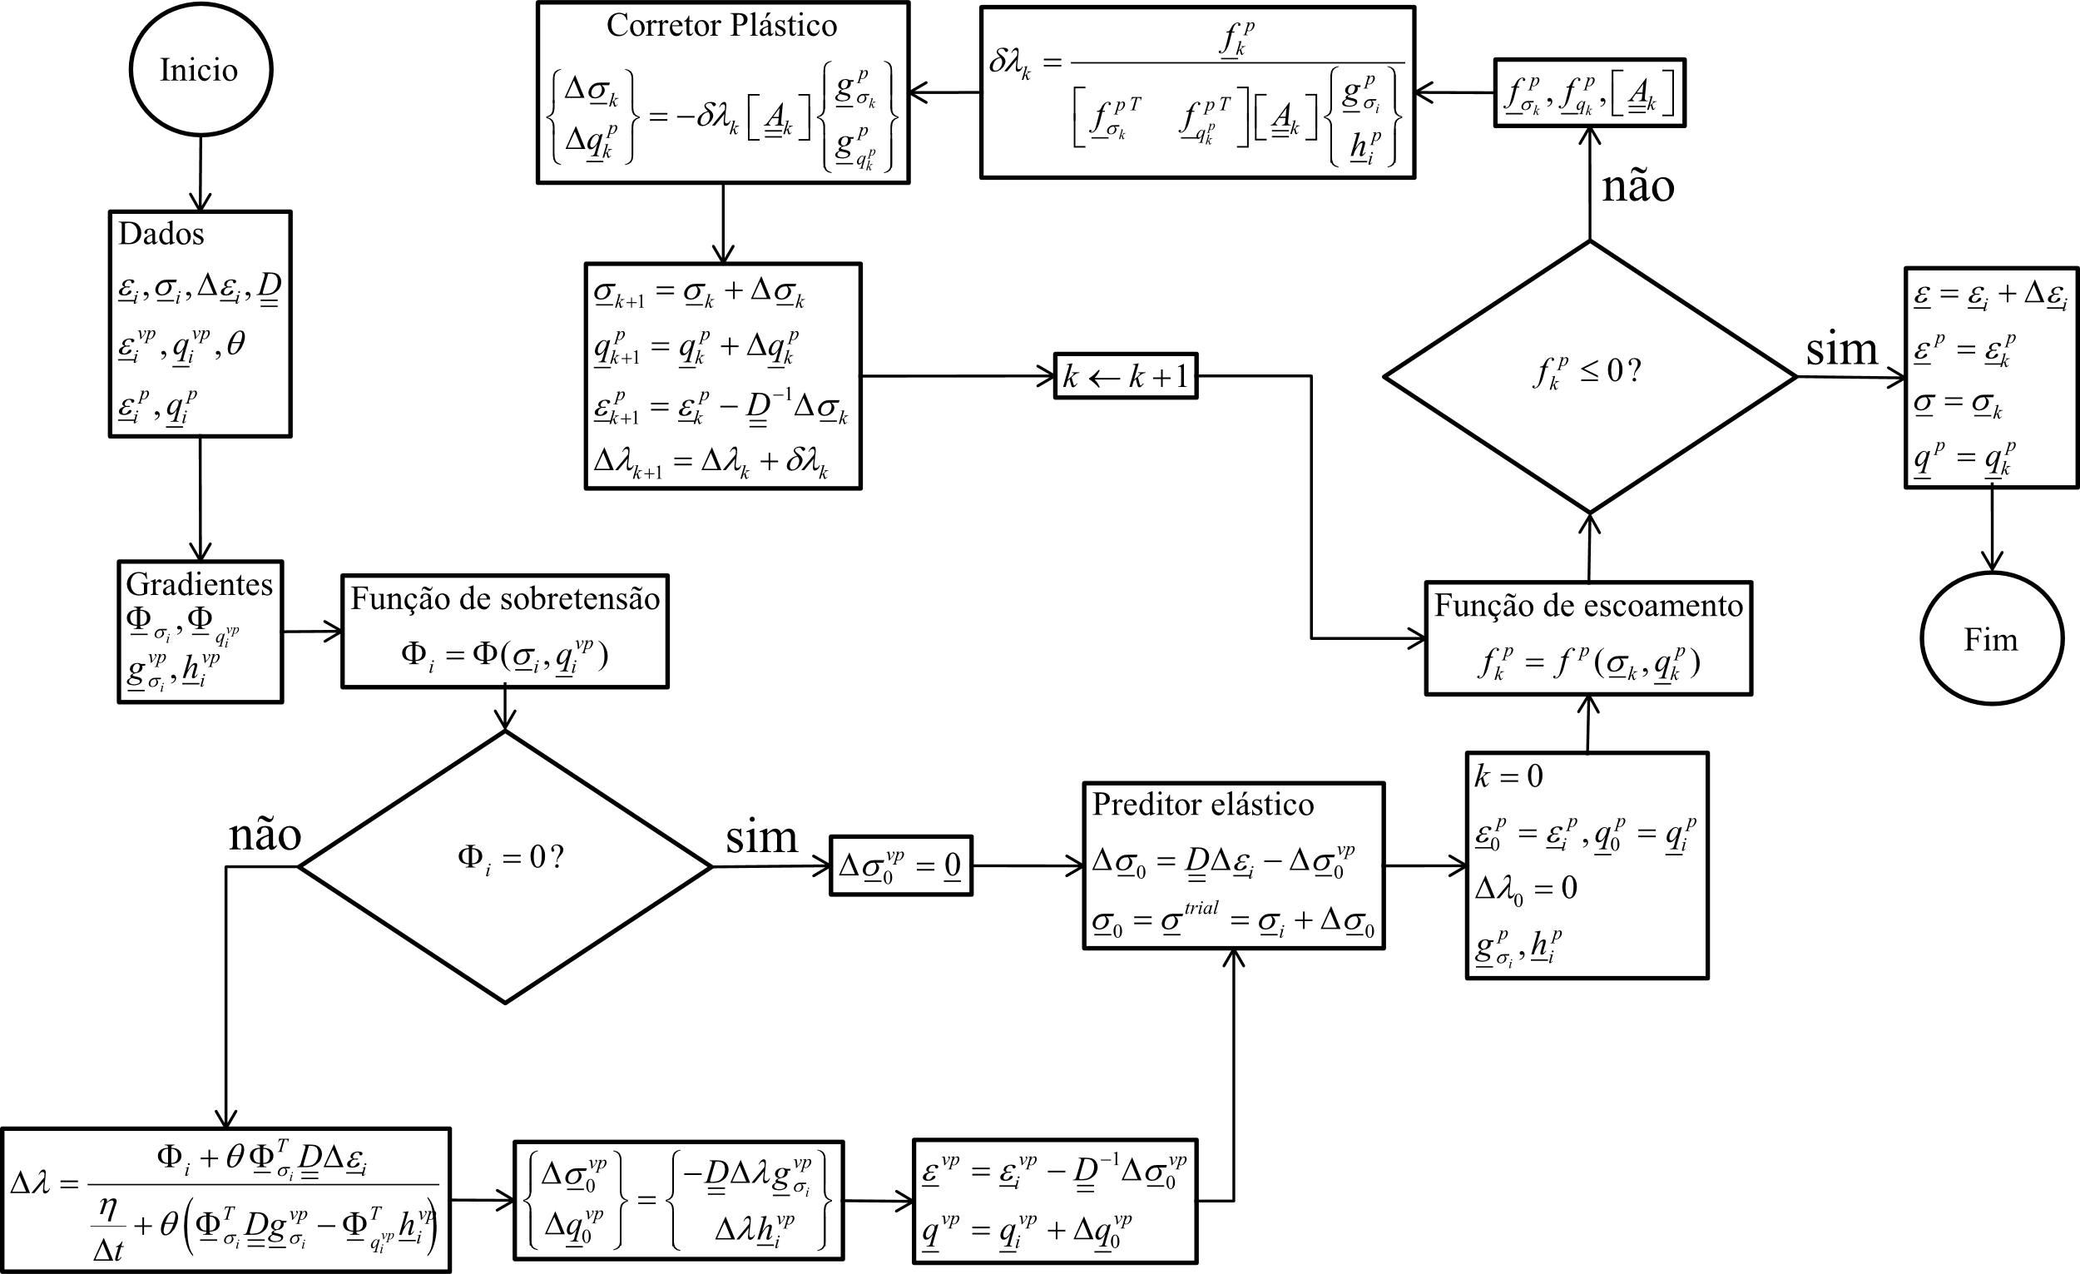

Figure 9. Integration algorithm for elastoplasticity-viscoplasticity using a semi-implicit Euler scheme (omitting the index )

1. Validation of the model

As validation, a comparison will be made with the analytical solution deduced by Piepi [5] for a perfect elastoplastic-viscoplastic model with Tresca’s criterion applied to deep clay rockmass. This analytical solution was chosen because it uses the same association principle as in Fig2 and will be compared with the numerical solution in axisymmetry. Furthermore, it is considered the same surface for plasticity and viscoplasticity, and their flux vectors are fully associated 

The mesh (Fig.10) comprises 1222 quadratic elements of eight nodes, two degrees of freedom per node and four integration points. The domain was divided into four areas to control spatial discretization. The system size, after applying the boundary conditions is of 7626 equations. The excavation method consisted of the technique of deactivating the elements to be excavated by multiplying the modulus of elasticity by 10-10 (eliminating its contribution to the stiffness matrix) and making the stresses to zero in the Gauss points during the integration of internal forces.

The viscous phenomenon evolves over time between excavation steps. This time is calculated as the ration between the step size of the excavation and the excavation speed. After the last excavation the model continues incrementing the time until the deformation increment is in the order of 10-8.

The geometric and physical parameters are shown in table 1 and table 2, respectively. In the latter, it can be noted that the elastoplastic model has greater cohesion than the viscoplastic model. This causes viscoplastic deformations to start even before the solid plasticize

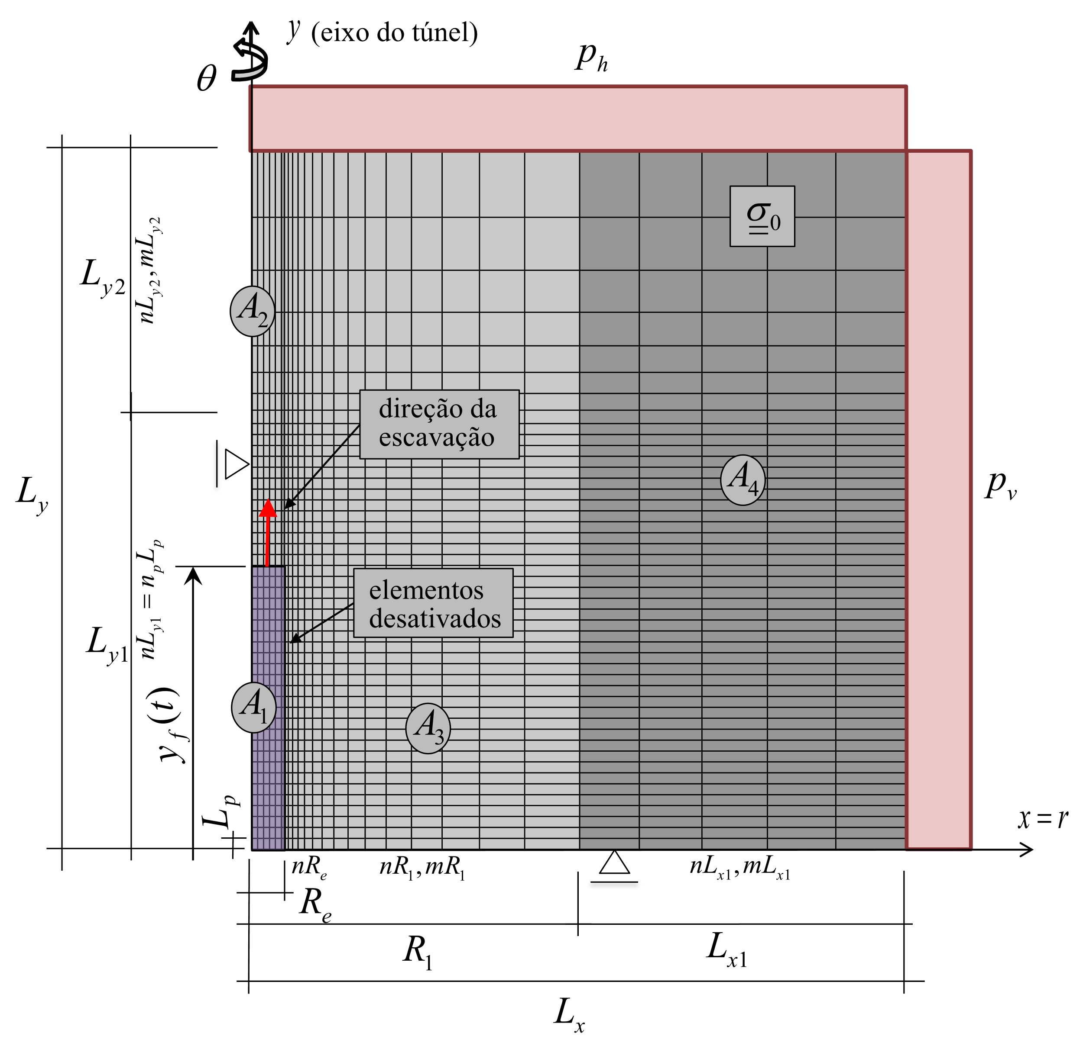

Figure 10. Domain, parameters, boundary conditions and the mesh of the axisymmetric numerical

Table 1. Geometric parameters of the axisymmetric model.

|  |  |  |  |
| --- | --- | --- | --- |
| **PARÂMETROS** | **SÍMBOLO** | **UNIDADE** | **VALORES** |
| GEOMETRIA | | | |
| Raio externo da seção | *Re* | m | 1 |
| Raio total do domínio | *Lx* | m | 20*Re* |
| Raio da região A3 (próxima ao túnel) | *R1* | m | 10*Re* |
| Comprimento do passo de escavação | *Lp* | m | *1/3Re* |
| Trecho do raio além da região A3 | *Lx1* | m | *Lx-R1* |
| Comprimento longitudinal total do domínio | *Ly* | m | *Ly1+Ly2* |
| Comprimento do trecho escavado | *Ly1* | m | *np*Lp* |
| Comprimento do trecho não escavado | *Ly2* | m | 25*Lp* |
| ESCAVAÇAÕ E COLOCAÇÃO DO REVESTIMENTO | | | |
| Número de passos de escavação | *np* | un | 39 |
| Número de passos na primeira escavação | *np1* | un | *3* |
| Tamanho do passo de escavação | *Lp* | m | 1/3*Re* |
| Cota da face de escavação | *yf* | m | *ip*Lp* |
| DISCRETIZAÇÃO | | | |
| Elementos ao longo de *Re* | *nRe* | un | *6* |
| Elementos ao longo de *R1* | *nR1* | un | 15 |
| Razão primeiro e o último elemento de *R1* | *mR1* | adm | 15 |
| Elementos ao longo de *Lx1* | *nLx1* | un | 5 |
| Razão primeiro e o último elemento de *Lx1* | *mLx1* | adm | 1,2 |
| Número de elementos ao longo de *Ly2* | *nLy2* | un | 8 |
| Razão primeiro e o último elemento de *Ly2* | *mLy2* | adm | 5 |

Tabela 2. Parâmetros físicos do maciço

|  |  |  |  |
| --- | --- | --- | --- |
| **PARÂMETROS** | **SÍMBOLO** | **UNIDADE** | **VALORES** |
| Módulo de Young | *E* | MPa | 2000 |
| Coeficiente de Poisson | *v* | adm | 0,498 |
| Tensão hidrostática geostática | *pv, ph, σ0* | MPa | 9 |
| Coesão (modelo elastoplástico) | *Cp* | MPa | 4 |
| Coesão (modelo viscoplástico) | *Cvp* | MPa | 3 |
| Constante de viscosidade dinâmica | *η* | MPa dia | *4*104* |
| Parâmetro da lei de potência | *n* | adm | *1* |
| Parâmetro convenientemente adotado | *f0* | MPa | *1* |
| Velocidade de escavação | *V* | m/dia | *1* |

The long-term convergence profile (closing of the tunnel section along the longitudinal length), that is, after the time-deferred effects cease, can be seen in the EP-VP curve in Fif.11. There is an excellent agreement between the proposed numerical solution and the analytical solution given by Piepi [5]. In addition, the convergence profile plotted for each individual model (E-Elastic, EP-Elastoplastic, VP-Viscoplastic and EP-VP elastoplastic-viscoplastic) showing the relevance of the long term phenomena. For VP model, the same cohesion of EP model was adopted, which means that in the long term, the convergences of the VP model are equal to the EP model.

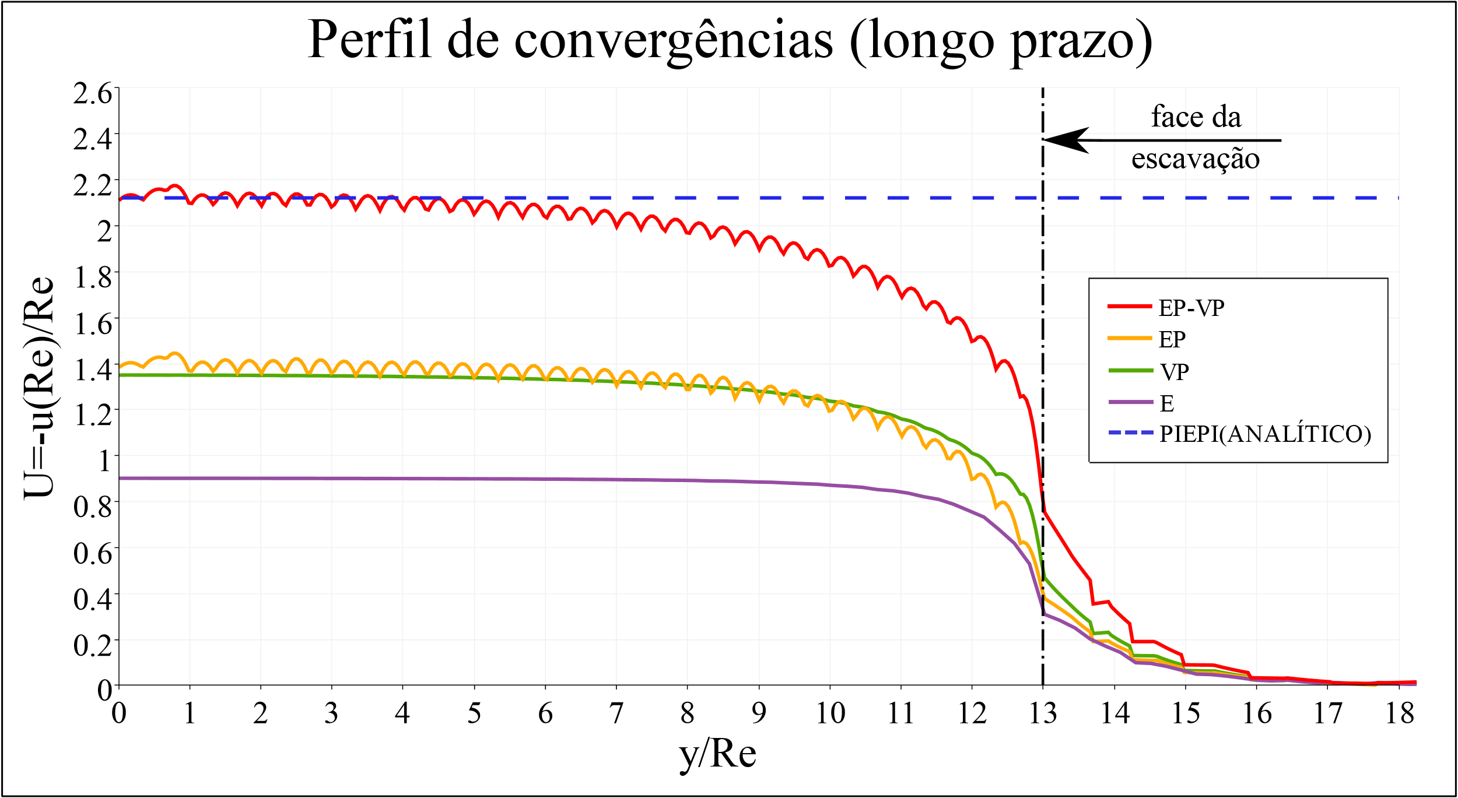

Figura 11. Perfil de convergências (longo prazo)

>>>>> colocar mais resultados e sobre a fig 11 falar do modelo EP-VP

1. Conclusions

This work was dedicated to present an effective numerical integration scheme for the elastoplastic-viscoplastic constitutive behavior with internal state variables that represent irrersible processes. For this purpose, a brief bibliographic review of each model was carried out separately and, subsequently, its coupling was carried out. Iterative global and local iteration schemes that involve solving this type of problem were also described. The comparison with an analytical solution considering the behavior of perfect materials demonstrated the effectiveness of the coupled algorithm. In addition, in the example studied, the convergence of the tunnel section without lining after stabilization using the elastoplastic-viscoplastic rockmass, was 53% greater than that of the isolated models, showing the relevance of this couple behavior.

References

[1] Rousset, G. *Comportement Mecanique des Argiles Profondes: application au stockage de déchets radioactifis*. 1988. Tese de Doutorado. École Nationale des Ponts et Chaussées, Paris. 1988.

[2] Barla, G.; Bonini, M.; Debernardi, D. Time dependent deformations in squeezing tunnels. *The 12th international conference of International association for computer methods and advances in geomechanics* (IACMAG), 2008, Goa, India.

[3] Ramoni, M.; Anagnostou, G. Thrust force requirements for TBMs in squeezing ground. *Tunnelling and Underground Space Technology*, v. 25, n. 4, p.433-455, 2010b.

[4] Manchao, H.; Xin, C.; Guofeng, Z.; Ziberio e Souza, L. Large deformation analysis in deep coal mines in china*. Innovative Numerical Modelling in Geomechanics. Innovative Numerical Modelling in Geomechanics*. CRC Press, p.333-353, 2012.

[5] G. T. Piepi. *Comportement viscoplastique avec rupture des argiles raides*. 1995. Tese de Doutorado. École Nationale des Ponts et Chaussées, Paris. 1995.

[6] A. Purwodihardjo; B. Cambou. Effect of strain-softening on settlement due to tunnelling in soft soil. *New Paradigms in Subsurface Prediction*, Springer, Berlin, Heidelberg, 2003, p. 173-188.

[7] A. Kleine. *Modélisation numérique du comportement des ouvrages souterrains par une approche viscoplastique*. 2007. Tese de Douturado. Institut National Polytechnique de Lorraine.

[8] M. S. Q. Shafiqu; M. R. Taha; Z. H. Chik. Finite element analysis of tunnels using the elastoplastic-viscoplastic bounding surface model. *ARPN Journal of Engineering and Applied Sciences*, v. 3, n. 3, p. 36-42, 2008.

[9] D. Debernardi; G. Barla. New viscoplastic model for design analysis of tunnels in squeezing conditions. *Rock Mechanics and Rock Engineering*, v. 42, n. 2, p.259-288, 2009.

[10] M. Souley; G. Armand; K. Su; M. Ghoreychi. Modeling the viscoplastic and damage behavior in deep argillaceus rocks. *Physics and Chemistry of the Earth*, Parts A/B/C, v. 36, n. 17-18, p. 1949-1959, 2011.

[11] H. T. Manh; J. Sulem; D. Subrin; D. Billaux. Anisotropic Time-Dependent Modeling of Tunnel Excavation in Squeezing Ground. *Rock Mechanics and rock Engineering*, v. 48, n. 6, p. 2301-2317, 2015.

[12] A. Vrakas; G. Anagnostou. A simple equation for obtaining finite strain solutions from small strain analyses of tunnels with very large convergences. *Géotechnique*, v. 65, n. 11, p. 936-944, 2015.

[13] W. F. Chen e D. Han. *Plasticity for structural engineers*. Springer-Verlag, 1988.

[14] E. A. de Souza Neto; D. Peric e D. R. J. Owen. *Computational Methods for plasticity: theory and applications*. John Wiley & Sons, 2008.

[15] O. C. Zienkiewicz e I. C. Cormeau. Visco-plasticity and creep in elastic solids: a unified numerical solution approach. *International Journal for Numerical Methods in Engineering*, v. 8, n. 4, p. 821-845, 1974.

[16] M. N. viladkar; J. Noorzaei e Godbole, P. N. Convenient forms of yield criteria in elasto-plastic analysis of geological materials. *Computers & Structures*, v. 54, n. 2, p. 327-337, 1995.

[17] F. H. Norton. *The creep of steels at high temperatures*. Mc-Graw-Hill, New York, 1929.

[18] J. Lemaitre; J. L. Caboche. *Mécanique des matériaux solides*. Dunod, 1996.

[19] J. J. Skrzypek. *Plasticity and creep. Theory, examples and problems*. London: CRC Press, 1993.

[20] P. Perzyna. Fundamental problems in viscoplasticityé. In: *Advances in applied mechanics*. Elsevier, 1966, p. 243-377.

[21] G. C. Nayak e O. C. Zienkiewicz. Elastic-plastic stress analysis: a generalization for various constitutive relations including strain softening. *International Journal for Numerical Methods in Engineering*, v. 5, n. 1, p. 113-135, 1972.

[22] O. C. Zienkieicz; S. Valliapan; I. P. King. Elasto-plastic solutions of engineering problems – the initial stress finite element approach. *International Journal for Numerical Methods in Engineering*, v. 1, n. 1, p. 75-100, 1969.

[23] J. Owen; E. Hinton. *Finite Elements in Plasticiy – Theory and Pratice*. Pinebridge Press, 1980.

[24] J. C. Simo e R. L. Taylor. Consistent tangente operators for rate-independent elastoplasticity. *Comput. Methods Appl. Mech. Eng.*, v. 49, n. 2, p. 221-245.

[25] T. Belytschko; W. K. Liu; B. Moran. *Nonlinear Finite Elements for Continua and Structures*. Jhon Wiley & Sons, 2000.

[26] J. C. Simo; T. J. R. Hughes. *Computational Inelasticity*. Springer-Verlag, New York, 1998.

[27] B. Moran; M. Ortiz; C. F. Shih. Formulation of implicit finite element methods for multiplicative finite deformation plasticity. *International Journal for Numerical Methods in Engineering*, v. 29, n. 3, p. 483-514, 1990.

[28] I. C. Cormeau. Numerical stability in quasi-static elasto/visco-plasticity. *International Journal for Numerical Methods in Engineering*, v. 9, n. 1, p.109-127, 1975.

[29] T. J. R. Hughes e R. L. Taylor. Unconditionally stable algorithms for quasi-static elasto/viscoplastic finite element analysis. *Computers & Structures*, v. 8, n. 2, p.169-173, 1978.

[30] J. M. M. C. Marques e D. R. J. Owen. Strain hardening representation for implicit quasistatic elasto-viscoplastic algorithms. *Computers & Structures*, v. 17, n. 2, p.301-304, 1983.

[31] D. Pierce; C. F. Shih; A. Needleman. A tangent modulus method for rate dependent solids, *Computers & Structures*, v. 18, n. 5, p. 875-887, 1984.

[32] D. Bernaud. *Tunnels profonds dans les milieux viscoplastiques: approches expérimentale et numérique*. 1991. Tese de Doutorado. Ecole Nationale des Ponts et Chaussées.

[33] J. Huang; D. V. Griffiths. Return mapping algorithms and stress predictors for failure analysis in geomechanics. *Journal of engineering mechanics*, v. 135, n. 4, p. 276-284, 2009.

[34] I. M. Smith; D. V. Griffiths; L. Margetts. *Programming the Finite Element Method*. 5. Ed, John Wiley & Sons, 2014.